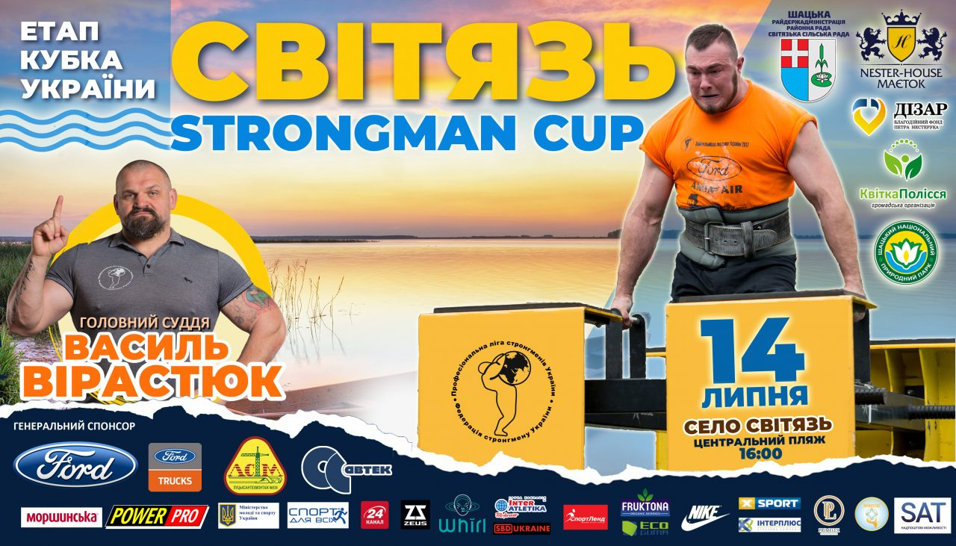
https://pershyj.com/p-stronmeni-zi-vsiyeyi-ukrayini-rozpochali-zmagannya-na-svityazi-foto-video-24313 32
https://www.youtube.com/watch?v=RcS7LViabu0 541
https://shatsk.rayon.in.ua/news/78642-svitiaz-strongman-sup-atleti-peretiaguvatimut-iahtu-i-provoditimut-konkursi-z-gliadachami 3107
http://visnyk.lutsk.ua/news/ukraine/regions/volyn/strongmeny-zi-vsiyeyi-ukrayiny-zmagayutsya-na-svityazi/ 221
https://www.youtube.com/watch?v=MQrdkx-sgks 737
https://www.youtube.com/watch?v=vjxfCg_FWpo 240
https://shatsk.rayon.in.ua/news/80749-torzhestvo-sili-i-mitsnosti-v-svitiazi-vidbuvsia-etap-kubka-ukrayini-zi-strongmenu 2186
https://konkurent.in.ua/news/volin/28117/ukrayinski-strongmeni-peretyaguvatimut-yahtu-u-svityazi.html 1150
https://pravda.lutsk.ua/%D0%B2%D1%96%D1%80%D0%B0%D1%81%D1%82%D1%8E%D0%BA-%D0%B7%D0%BB%D0%B8%D0%B2%D0%B0-%D1%82%D0%B0-%D0%BA%D0%B0%D1%82%D0%B0%D0%BC%D0%B0%D1%80%D0%B0%D0%BD-%D1%8F%D0%BA-%D0%BD%D0%B0-%D1%81%D0%B2%D1%96%D1%82/
https://pershyj.com/p-sila-ta-draiv-yak-na-plyazhi-svityazyu-zmagalisya-bogatiri-foto-video-24335

