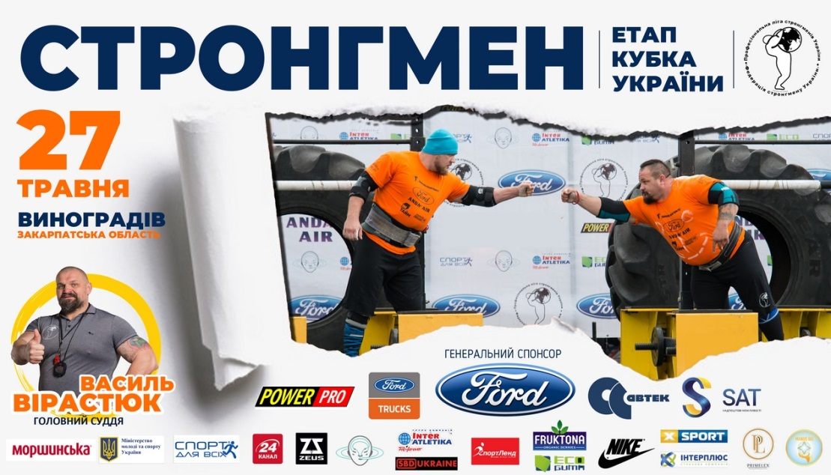
https://www.youtube.com/watch?v=xBOv3s02A-8 103
https://www.youtube.com/watch?v=8wVVyqQICl4 369
http://vynohradivnews.in.ua/novini/vynohradivshina/23934-u-vinogradov-organzovuyut-festival-sportu.html 446
https://goloskarpat.info/sport/5b0c3f732f4a8/?utm_content=03143 4206

