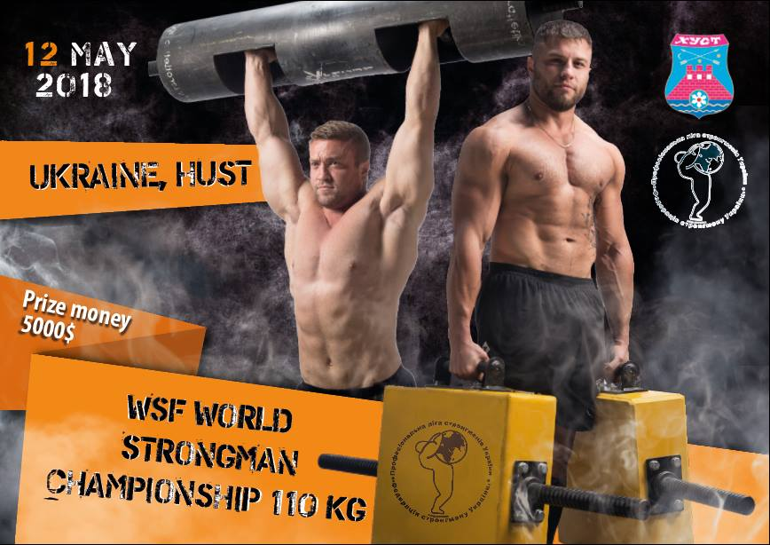

https://www.youtube.com/watch?v=qBvFg1pAHVg 2719
https://www.youtube.com/watch?v=20oul6gBqbU 860
http://transkarpatia.net/transcarpathia/hot-news/97385-hust-zbiraye-naysilnshih-lyudey-svtu-na-chemponat.html 551
http://transkarpatia.net/transcarpathia/sports/97501-vpershe-u-hust-proveli-masshtabn-zmagannia-z-strongmenu-vdeo.html 1219
http://mukachevo.today/foto/sport/u_husti_viznachili_chempiona_svitu_zi_strongmenu_(foto) 145
https://zakarpattya.net.ua/News/181544-U-KHusti-na-Zakarpatti-vidbuvsia-World-Strongman-Championship-110-kg-FOTO-VIDEO
https://pmg.ua/life/70241-u-khusti-vidbudutsya-zmagannya-naysylnishykh-lyudey-svitu 684
https://pershij.com.ua/zmahannia-naisylnishykh-u-khusti-stronhmeny-boriutsia-za-prestyzhnyi-tytul/ 340
https://www.facebook.com/rtkkhust/videos/656180088053681/UzpfSTEwMDAwOTc4MTk1ODI3Mjo2Njc4NzI3NTM1NDg3ODQ/ 941
https://www.youtube.com/watch?v=f64jkStblXM&feature=share&app=desktop 324
https://www.facebook.com/mstudio.tv/videos/1649612101754986/UzpfSTEwMDAwOTc4MTk1ODI3Mjo2Njc3NjIwNzY4OTMxODU/ 11000
https://sport.ua/news/385150-strongmen-kochergin-chempion-svitu 2404
http://mediakhust.net/2018/05/13/yak-u-husti-zmahalysya-najbilshi-sylachi-svitu-scho-pro-tse-dumaje-vasyl-virastyuk-foto/ 8872
Загальна кількість переглядів понад 30059 чол.

